Craig Plazony

ECE 505

Deliverable 2

For this deliverable I will dive into my research questions to see if they are answerable and good questions.

1. Is one fuel better than the other for the purposes of Average Miles Per Gallon?

This question is not as simple as I thought it might be. Idle % time is important to consider when doing this evaluation and that data appears to be mostly missing. It exists for the later part of the year, but the data is the same for both fuel types. So, for this, we must assume the idle time was the same for both fuel types on average. This means we will only look at the Average Fuel Economy statistics. The other assumption I will have to make is these data points all come from the same trucking routes. If vehicles vary in height while driving this causes significant fuel efficiency loss.

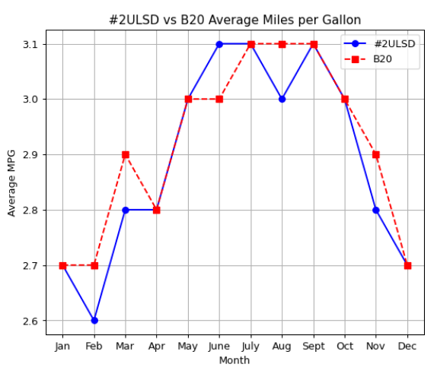

Figure 1. Line graph comparing the Average Fuel Economy between #2ULSD and B20 biofuels month to month

By visual inspection, it does not appear to have much of a difference between average gas mileage (AMPG). #2ULSD AMPG has a mean of 2.89 while B20 AMPG has a mean of 2.91. They are practically the same value. What is interesting is that there may be a difference based on the time of year.

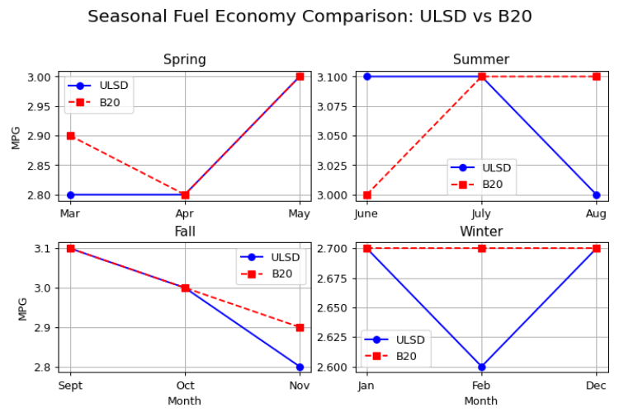

Figure 2 Side-by-sides of the AMPG during the different seasons

One again it looks like these are all relatively close based on the differences between them. There seems to be no meaningful way to differentiate the 2 biofuels based on their AMPG. I believe that this answers this question, but it leaves many questions I wish I could ask. Where are the missing idle times? Did these trucks take the same route? Were all the trucks the same type? I don’t feel satisfied that I can answer this question with good accuracy.

2. Is one fuel better than the other for the purposes of particulate emissions in their exhaust?

This question is even more meaningful since AMPG does not seem to matter between the 2 biofuels. My first comparison will just be comparing the average of all the particulate emissions together.

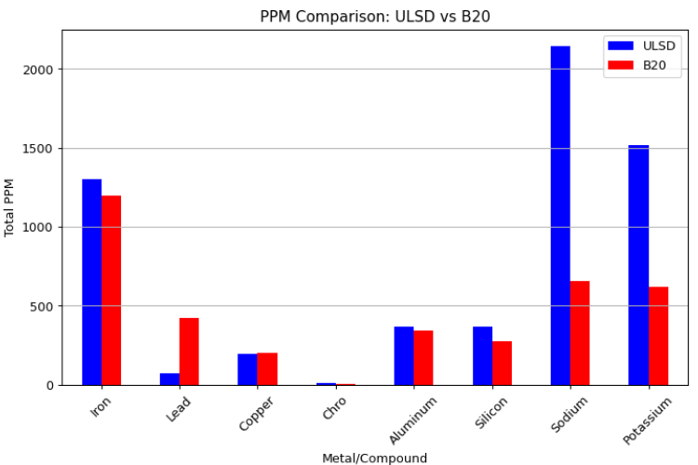

Figure 3 Comparison of the various particulates in the biofuel emissions. These are totals in all particulates from all samples taken

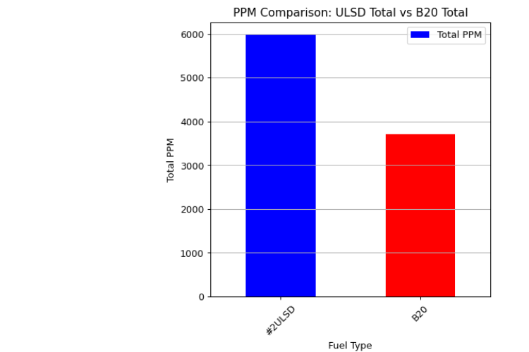

Figure 4 Direct comparison of the aggregate number of particulates in both biofuels from all samples

Glancing at pure totals of particulates. #2ULSD has nearly twice as many particulates as B20. On the surface, this would seem #2 is much worse that B20. But, as the 1st graph shows, there is not the same amount of each particulate. In particular, lead is much higher in B20 and it is known to be a dangerous element to have in our atmosphere. What I would like to see from here is a comparison of how dangerous each of these elements are to give them weight to how bad each one is. I think this question is still a good question.

3. Are there relationships between base/acid levels and the particulate in the exhaust?

In the 90s, acid rain was a big deal so this issue interests me quite a bit. Acidity levels from car exhaust were a problem and it was eventually brought down so it isn’t an issue.

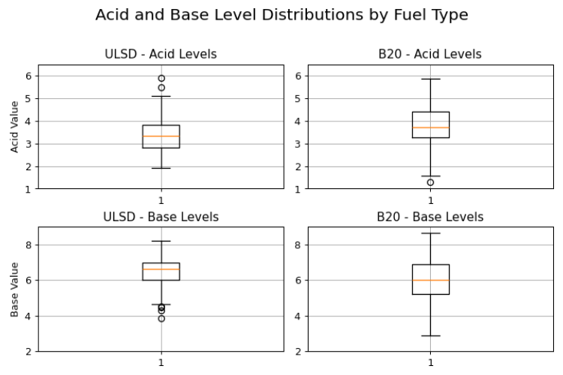

Figure 5 Boxplots of the Acid and Base numbers of the different biofuels

First observation is that, on average, #2ULSD has a lower average Total Acid Number (TAN) and a higher Total Base Number (TBN). Both are positive indicators for the health of oil which is in exhaust. This means that #2USLD is either better than B20 for engine oil or there are other external factors I am missing from this data such as a large difference in engine oil types. B20 also has a larger variance which would mean it’s less reliable from an expectations standpoint. I believe this data can answer my question.

Summary “Tweet”

Using real world data from a Class 8 trucking fleet, we compare B20 and #2ULSD biodiesel to evaluate fuel economy and exhaust composition. Can biofuels reduce emissions without sacrificing the environment? Our analysis explores the tradeoffs.

Keywords

- Fuel economy

- Biodiesel

- ULSD

- Emissions

- Seasonal variation

- Engine performance

- Particulate matter